6 Painting and Sculpting
Painting & Sculpting 2
Painting 3
Texture Paint 3
Getting Started 4
Texture Preview 5
Brushes Settings 5
Brush 6
Types of brushes 6
Texture 7
Stroke 8
Curve 9
Paint options 9
Overlay 9
Appearance 9
Saving 9
Using an External Image Editor 9
Known Limitations 10
UV Overlap 10
Perspective View & Faces Behind the View 10
Perspective View & Low Poly 10
Vertex Paint 10
Introduction 10
Settings 11
Brush 13
Texture 14
Stroke 15
Curve 16
Options 17
Overlay 17
Appearance 17
Options 17
Weight Paint 17
Weight Paint in a nutshell 18
The weighting Color Code 18
Brushes 19
The main brush properties 19
Normalize Options 20
The Brush stroke definition 21
The brush Falloff curve 22
The brush appearance 22
Brush presets 22
Customizing brush color space 23
Selection Masking 23
Details about selecting 23
Vertex Selection Masking 24
Face Selection Masking 24
Hide/Unhide Faces 25
Hide/Unhide Vertices 25
The Clipping Border 25
Weight Paint Options 26
Weight Paint Tools 27
Weight Painting for Bones 27
Weight Painting for Particles 28
Weight Tools 28
The Subset Option 29
Normalize All 29
Operator Parameters 30
Normalize 30
Mirror 30
Operator Parameters 31
Invert 31
Operator Parameters 32
Clean 32
Operator Parameters 33
Levels 33
Operator Parameters 34
Blend 34
Operator Parameters 36
Transfer Weights 36
Prepare the Copy 36
Call the Tool 36
Redo Panel Confusion 37
Workaround 37
Operator Parameters 37
Limit Total 37
Operator Parameters 37
Weight Gradient 37
Operator Parameters 38
Sculpting 38
Overview 38
Sculpt Mode 38
Sculpt Brushes 39
Sculpt Properties Panel 41
Brush Panel 41
Stroke Panel 41
Curve Panel 42
Texture Panel 42
Symmetry Panel 43
Overlay Panel 43
Options Panel 44
Appearance Panel 44
Sculpt Menus 44
Tool Menu 44
Hiding and Masking Mesh 44
Adaptive Sculpting 45
Dynamic Topology 45
Multi-Resolution Modifier 46

Painting & Sculpting

TODO.

Painting

TODO.

Texture Paint

A UV Texture is a picture (image, sequence or movie) that is used to color the surface of a mesh. The UV Texture is mapped to the mesh through one or more UV maps. There are three ways to establish the image used by the UV Texture:
- Paint a flat image in the UV/Image Editor onto the currently selected UV Texture, using its UV map to transfer the colors to the faces of the mesh.
- Paint the mesh in the 3D View, and let Bforartists use the currently selected UV map to update the UV Texture (see Projection Painting).
- Use any image-editing (paint) program to create an image. In the UV/Image Editor, select the UV Texture and load the image. Bforartists will then use that texture’s UV map to transfer the colors to the faces of the mesh
Bforartists features a built-in paint mode called Texture Paint which is designed specifically to help you edit your UV Textures and images quickly and easily in either the UV/Image Editor window or the 3D View window. Since a UV Texture is just a special-purpose image, you can also use any external paint program. For example, GIMP is a full-featured image manipulation program that is also open-source.
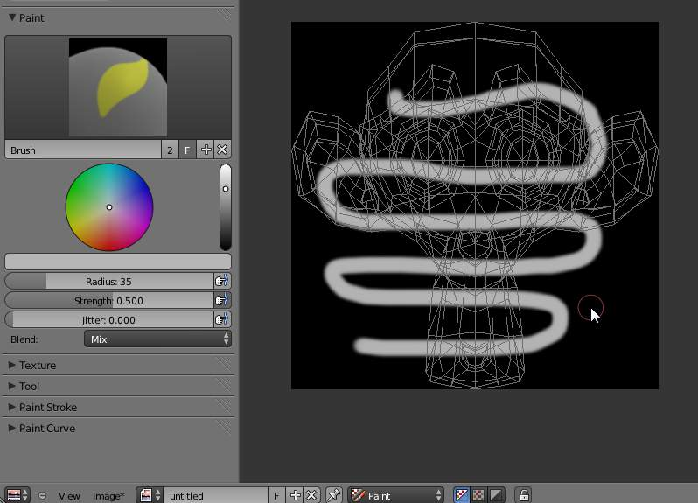
Texture painting in Bforartists
Since a mesh can have layers of UV Textures, there may be many images that color the mesh. However, each UV Texture only has one image.
Texture Paint works in both a 3D window and the UV/Image Editor window. In the 3D window in Texture Paint mode, you paint directly on the mesh by projecting onto the UVs.

Getting Started
Once you have unwrapped your model to a UV Map (as explained in previous pages), you can begin the texturing process. You cannot paint on a mesh in Texture Paint mode without first unwrapping your mesh, and doing one of the following steps. Either:
See: Applying Textures.
After you have done one of these two things, you can modify the image using the Texture Paint mode:
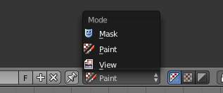
Enabling paint mode
- In the 3D View window, select Texture Paint mode from the mode selector in the window header, and you can paint directly onto the mesh.
- In the UV/Image Editor window, switch the editing context from View to Paint (shown to the right).
Note
Square Power of 2
Texture paint is very fast and responsive when working in the 3D window and when your image is sized as a square where the side lengths are a power of two, e.g. 256x256, 512x512, 1024x1024, etc.

Once you enable Texture Painting, your mouse becomes a brush. To work with the UV layout (for example, to move coordinates) you must go back to “View” mode.
As soon as you enable Texture Painting or switch to Texture Paint mode, brush settings become available in the Toolbar Panel (T-key).
In the UV/Image Editor window, you paint on a flat canvas that is wrapped around the mesh using UV coordinates. Any changes made in the UV/Image Editor window show up immediately in the 3D window, and vice versa.
A full complement of brushes and colors can be selected from the Properties panel in the UV/Image Editor. Brush changes made in either panel are immediately reflected in the other panel. However, the modified texture will not be saved automatically; you must explicitly do so by Image–>Save in the UV/Image Editor window.

Texture Preview
If your texture is already used to color, bump map, displace, alpha-transparent, etc., a surface of a model in your scene (in other techie words, is mapped to some aspect of a texture via a texture channel using UV as a map input), you can see the effects of your painting in the context of your scene as you paint.
To do this, set up side-by-side windows, one window in 3D View set to Textured display mode, and the second UV/Image Editor window loaded with your image. Position the 3D View to show the object that is UV mapped to the loaded image. Open a Preview window (see 3D View Options for more info) and position it over the object. In the image to the right, the texture being painted is mapped to the “Normal” attribute, and is called “bump mapping”, where the gray-scale image is used to make the flat surface appear bumpy. See Texture Mapping Output for more information on bump mapping.

Brushes Settings
Press T in the UV/Image Editor to show the Toolbar panel. With this panel, you can create many brushes, each with unique settings (such as color and width). Use the Brush selector to switch between brushes, or to create a new brush. When you add a brush, the new brush is a clone of the current one. You can then change the setting for the new brush. Texture paint has an unlimited number of brushes and unique user-defined controls for those brushes which can be set in the Paint Tool panel.
To use a brush, click on its name. Use the selector up/down arrow, if there are more brushes on the flyout window than can be displayed at once. Name your brush by clicking on the name field and entering any name you wish, such as “Red Air” for a red airbrush. To toss out a brush, click the brush delete X button next to its name. If you want to keep this brush around for the next time you run Bforartists, click the Fake user button (F) next to the brush delete (X) button.
If you have a tablet pen with pressure sensitivity, toggle the small “P” button next to the opacity, size, falloff and spacing buttons to control these parameters using the pressure of the pen. Using your pen’s eraser end will toggle on the Erase Alpha mode.
Press S on any part of the image to sample that color and set it as the brush color.

Brush
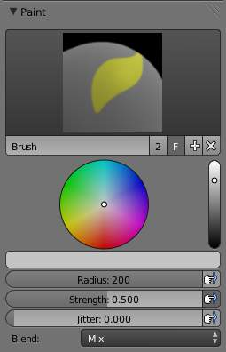
Brush Settings
Brush presets
Select a preset brush. Most brushes have common settings.

Types of brushes
There are four different types of brushes
Draw
the normal brush; paints a swath of color
Soften
blends edges between two colors
Smear
when you click, takes the colors under the cursor, and blends them in the direction you move the mouse. Similar to the “smudge” tool of Gimp.
Clone
copies the colors from the image specified (Tex.Dirt in the example), to the active image. The background image is shown when this brush is selected; use the B lend slider to control how prominent the background image is.
Enable Pressure Sensitivity
The icon to the right of the following three settings will enable or disable tablet pressure sensitivity to control how strong the effect is.
Color
The color of the brush
Radius
The radius of the brush in pixels
Strength
How powerful the brush is when applied}}
Blend
Set the way the paint is applied over the underlying texture
- Mix: the brush color is mixed in with existing colors
- Add: the brush color is added to the existing color; green added to red gives yellow.
- Subtract: the brush color is subtracted; painting blue on purple gives red
- Multiply: the RGB value of the base is multiplied by the brush color
- Lighten: the RGB value of the base color is increased by the brush color
- Darken: tones down the colors
- Erase Alpha: makes the image transparent where painted, allowing background colors and lower-level textures to show through. As you ‘paint’, the false checkerboard background will be revealed
- Add Alpha: makes the image more opaque where painted
In order to see the effects of the Erase and Add Alpha mix modes in the UV/Image Editor, you must enable the alpha channel display by clicking the Display Alpha or the Alpha-Only button. Transparent (no alpha) areas will then show a checkered background.
Image
When using the clone brush, this allows you to select an image as a clone source.
Alpha
Opacity of the clone image display

Texture
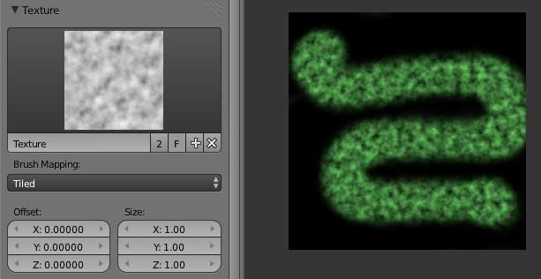
Texture options and example
Use the texture selector at the bottom of the paint panel to select a pre-loaded image or procedural texture to use as your brush pattern. Note that in order to use it, you must have a placeholder material defined, and that particular texture defined using the Material and Texture buttons. It is not necessary to have that material or texture applied to any mesh anywhere; it must only be defined. The example to the right shows the effects of painting with a flat (banded) wood texture. Switching the texture to Rings makes a target/flower type of brush painting pattern.
Note
In Clone paint mode, this field changes to indicate the picture image or texture that you are cloning from.

Brush Mapping
Sets how the texture is applied to the brush
View Plane
In 2D painting, the texture moves with the brush
Tiled
The texture is offset by the brush location
3D
Same as tiled mode
Stencil
Texture is applied only in borders of the stencil.
Random
Random applying of texture.
Angle
This is the rotation angle of the texture brush. It can be changed interactively via Ctrl-F in the 3D view. While in the interactive rotation you can enter a value numerically as well. Can be set to:
User
Directly input the angle value.
Rake
Angle follows the direction of the brush stroke. Not available with 3D textures.
Random
Angle is randomized.
Offset
Offset the texture in x, y, and z.
Size
Set the scale of the texture in each axis.

Stroke
Stroke Method
Allows set the way applying strokes.
Airbrush
Flow of the brush continues as long as the mouse click is held, determined by the Rate setting. If disabled, the brush only modifies the color when the brush changes its location.
Rate
Interval between paints for airbrush
Space
Creates brush stroke as a series of dots, whose spacing is determined by the Spacing setting.
Spacing
Represents the percentage of the brush diameter. Limit brush application to the distance specified by spacing.
Dots
Apply paint on each mouse move step
Jitter
Jitter the position of the brush while painting
Smooth stroke
Brush lags behind mouse and follows a smoother path. When enabled, the following become active:
Radius
Sets the minimun distance from the last point before stroke continues.
Factor
Sets the amount of smoothing.
Input Samples
Average multiple input samples together to smooth the brush stroke.
Wrap
wraps your paint to the other side of the image as your brush moves off the OTHER side of the canvas (any side, top/bottom, left/right). Very handy for making seamless textures.

Curve
The paint curve allows you to control the falloff of the brush. Changing the shape of the curve will make the brush softer or harder.
Note
- Read more about using the Curve Widget.

Paint options

Overlay
Allows you to customize the display of curve and texture that applied to the brush.

Appearance
Allows you to customize the color of the brush radius outline, as well as specify a custom icon.

Saving
If the header menu item Image has an asterisk next to it, it means that the image has been changed, but not saved. Use the Image–>Save Image option to save your work with a different name or overwrite the original image.
Note
UV Textures
Since images used as UV Textures are functionally different from other images, you should keep them in a directory separate from other images.

The image format for saving is independent of the format for rendering. The format for saving a UV image is selected in the header of the Save Image window, and defaults to PNG (.png).
If Packing is enabled in the window header, or if you manually Image–>Pack Image, saving your images to a separate file is not necessary.

Using an External Image Editor
If you use an external program to edit your UV Texture, you must:
- run that paint program (GIMP, Photoshop, etc.)
- load the image or create a new one
- change the image, and
- re-save it within that program.
- Back in Bforartists, you reload the image in the UV/Image Editor window.
You want to use an external program if you have teams of people using different programs that are developing the UV textures, or if you want to apply any special effects that Texture Paint does not feature, or if you are much more familiar with your favorite paint program.

Known Limitations

UV Overlap
In general overlapping UVs aren’t supported (as with texture baking).
However this is only a problem when a single brush stroke paints onto multiple faces that share a texture.

Perspective View & Faces Behind the View
When painting onto a face which is partially behind the view (in perspective mode), the face can’t be painted on. To avoid, this zoom out or use an Ortho mode viewport.

Perspective View & Low Poly
When painting onto a face in perspective mode onto a low poly object with normals pointing away from the view, painting may fail; to workaround disable the Normal option in the paint panel.
Typically this happens when painting onto the side of a cube

Vertex Paint

- Introduction
  - Settings
  - Options

Introduction

Vertex Painting is a simple way of painting color onto an object, by directly manipulating the color of vertices, rather than textures, and is fairly straightforward.
When a vertex is painted, the color of the vertex is modified according to the rules of the ‘brush’. The color of all visible planes and edges attached to the vertex are then modified with a gradient to the color of the other connected vertices. (Note that the color of non-visible faces are not modified).
Vertex colors can be painted by first going into Edit Mode, then switching to Vertex Paint Mode; however, it will not show up in the render unless you check “Vertex Color Paint” in the Materials Options Panel.
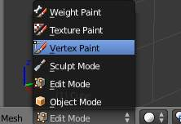
Vertex Painting Mode
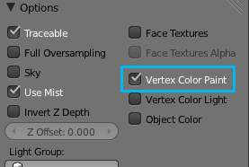
Check this box

Settings
The Tools Shelf, shortcut T contains most of the options for vertex painting. The following sections describe the controls in each of the available panels.
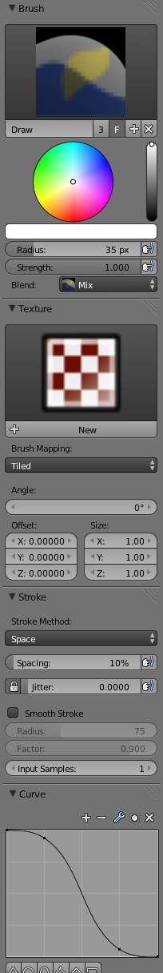
Settings for vertex painting

Brush
Brush Data-Block
The image, name panel and color selector at the top allows you to select brush presets, rename brushes, as well as add custom brushes, and delete them.
Radius
Set the radius of the brush
Strength
Set the strength of the brush’s effect.
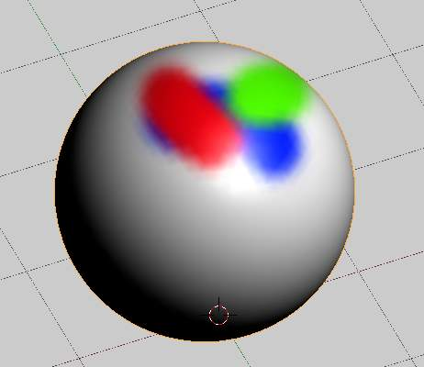
Mix overlay with full strength
Blend menu
Mix
Mixes RGB values. When set to a strength of 1.0, it will cover the underlying “paint”.
Add
Adds RGB values. Will eventually turn the entire object white as RGB values accumulate to 1.0-1.0-1.0: Pure White.
Subtract
Subtracts RGB values. Usually results in Black.
Multiply
Multiplies brush colors by the vertex colors.
Blur
Blurs vertex colors.
Lighten
Lightens the color of the vertices.
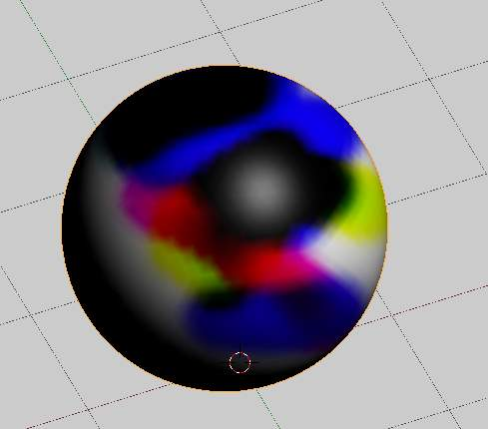
Subtract with full strength
Darken
Darkens the color of the vertices.

Texture
Use the texture selector at the bottom of the paint panel to select a pre-loaded image or procedural texture to use as your brush pattern. Note that in order to use it, you must have a placeholder material defined, and that particular texture defined using the Material and Texture buttons. It is not necessary to have that material or texture applied to any mesh anywhere; it must only be defined.
Brush Mapping Mode
Sets how the texture is applied to the brush
View Plane
In 2D painting, the texture moves with the brush
Tiled
The texture is offset by the brush location
3D
Same as tiled mode
Stencil
Texture is applied only in borders of the stencil.
Random
Random applying of texture.
Angle
This is the rotation angle of the texture brush. It can be changed interactively via Ctrl-F in the 3D view. While in the interactive rotation you can enter a value numerically as well. Can be set to:
User
Directly input the angle value.
Rake
Angle follows the direction of the brush stroke. Not available with 3D textures.
Random
Angle is randomized.
Offset
Offset the texture in x, y, and z.
Size
Set the scale of the texture in each axis.

Stroke
Stroke Method
Allows set the way applying strokes.
Airbrush
Flow of the brush continues as long as the mouse click is held, determined by the Rate setting. If disabled, the brush only modifies the color when the brush changes its location.
Rate
Interval between paints for airbrush
Space
Creates brush stroke as a series of dots, whose spacing is determined by the Spacing setting.
Spacing
Represents the percentage of the brush diameter. Limit brush application to the distance specified by spacing.
Dots
Apply paint on each mouse move step
Jitter
Jitter the position of the brush while painting
Smooth stroke
Brush lags behind mouse and follows a smoother path. When enabled, the following become active:
Radius
Sets the minimun distance from the last point before stroke continues.
Factor
Sets the amount of smoothing.
Input Samples
Average multiple input samples together to smooth the brush stroke.
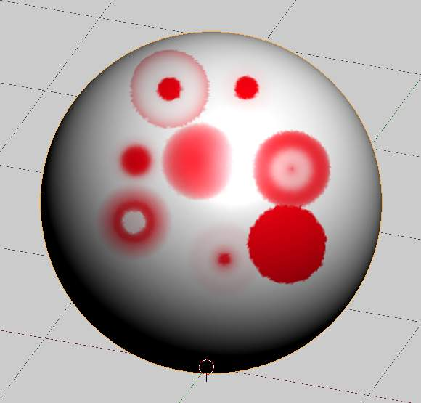
Various brush curves

Curve
Brush Curves affect how strongly the color is applied depending on distance from the center of the brush. In other words, they allow you to edit the Falloff of the brush intensity.

Options
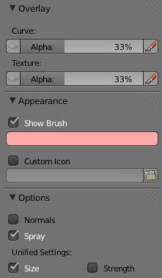
Options for vertex painting

Overlay
Allows you to customize the display of curve and texture that applied to the brush.

Appearance
Allows you to customize the color of the brush radius outline, as well as specify a custom icon.

Options
Normals
Applies the Vertex Normal before painting. This does not usually affect painting.
Spray
Continues painting for as long as the mouse is held.
Unified Settings
Size
All brushes use the same size.
Strength
All brushes use the same strength.

Weight Paint

Vertex Groups can potentially have a very large number of associated vertices and thus a large number of weights (one weight per assigned vertex). Weight Painting is a method to maintain large amounts of weight information in a very intuitive way. It is primarily used for rigging meshes, where the vertex groups are used to define the relative bone influences on the mesh. But we use it also for controlling particle emission, hair density, many modifiers, shape keys, etc.
The basic principle of the method is: the weight information is literally painted on top of the Mesh body by using a set of Weight brushes. And since painting is always associated with color, we also need to define ...

Weight Paint in a nutshell
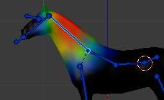
Weight Painted Vertex Group
- You enter Weight Paint mode from the Mode Menu (Ctrl-Tab). The selected Mesh Object is displayed slightly shaded with a rainbow color spectrum.
- The color visualizes the weights associated to each vertex in the active Vertex Group. Blue means unweighted; Red means fully weighted.
- You can customize the colors in the weight gradient by enabling Custom Weight Paint Range in the System tab of the User Preferences.
- You assign weights to the vertices of the Object by painting on it with weight brushes. Starting to paint on a mesh automatically adds weights to the active Vertex Group (a new Vertex Group is created if needed).

The weighting Color Code
Weights are visualized by using a cold/hot color system, such that areas of low influence (with weights close to 0.0) are drawn in blue (cold) and areas of high influence (with weights close to 1.0) are drawn in red (hot). And all in-between influences are drawn in rainbow colors, depending on their value (blue, green, yellow, orange, red)
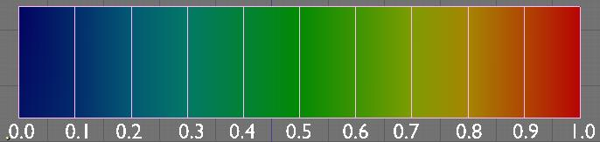
Image 3: The color spectrum and their respective weights.
In addition to the above described color code, Bforartists has added (as an option) a special visual notation for unreferenced vertices: They are drawn in black. Thus you can see the referenced areas (drawn in cold/hot colors) and the unreferenced areas (in black) at the same time. This is most practical when you look for weighting errors (we will get back to this later).

Brushes
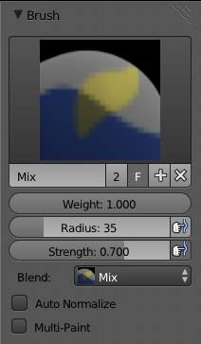
The Brush panel in the Tool Shelf
Painting needs paint brushes and Bforartists provides a Brush Panel within the Tool Shelf when it operates in Weight Paint Mode. You find predefined Brush Presets when you click on the large Brush Icon at the top of the brush Panel. And you can make your own presets as needed. See below for the available brush presets and to create custom presets.

The main brush properties
The most important and frequently modified properties are:
Weight
The weight (color) to be used by the brush. However, the weight value is applied to the Vertex Group in different ways depending on the selected Brush Blending mode (see below).
Strength
This is the amount of paint to be applied per brush stroke. What that means exactly also depends on the Brush Blending mode.
Radius
The radius defines the area of influence of the brush.
Note
You can also change the Brush radius with a keyboard shortcut while painting. Just press F at any time, then drag the mouse to increase/reduce the brush radius. Finally click LMB to use the new setting. Or press the Esc key at any time to return to the current settings.

Blend mode
The brush Blending mode defines in which way the weight value is applied to the Vertex Group while painting.
Mix
In this Blend mode the Weight value defines the target weight that will eventually be reached when you paint long enough on the same location of the mesh. And the strength determines how many strokes you need to arrive at the target weight. Note that for strength = 1.0 the target weight is painted immediately, and for Weight = 0.0 the brush just does nothing.
Add
In this blend mode the specified weight value is added to the vertex weights. The strength determines which fraction of the weight gets added per stroke. However, the brush will not paint weight values above 1.0.
Subtract
In this blend mode the specified weight is subtracted from the vertex weights. The strength determines which fraction of the weight gets removed per stroke. However the brush will not paint weight values below 0.0.
Lighten
In this blend mode the specified weight value is interpreted as the target weight very similar to the Mix Blend mode. But only weights below the target weight are affected. Weights above the target weight remain unchanged.
Darken
This Blend mode is very similar to the Lighten Blend mode. But only weights above the target weight are affected. Weights below the target weight remain unchanged.
Multiply
Multiplies the vertex weights with the specified weight value. This is somewhat like subtract, but the amount of removed weight is now dependent on the Weight value itself.
Blur
tries to smooth out the weighting of adjacent vertices. In this mode the Weight Value is ignored. The strength defines how effectively the blur is applied.

Normalize Options
Bforartists also provides Options regarding the automatic normalizing of all affected Vertex groups:
Auto Normalize
Ensures that all deforming vertex groups add up to 1 while painting. When this option is turned off, then all weights of a vertex can have any value between 0.0 and 1.0. However, when Vertex Groups are used as Deform Groups for character animation then Bforartists always interprets the weight values relative to each other. That is, Bforartists always does a normalization over all deform bones. Hence in practice it is not necessary to maintain a strict normalization and further normalizing weights should not affect animation at all.
This option works most intuitively when used to maintain normalization while painting on top of weights that are already normalized with some other tool.
Multi-Paint
Paint on all selected Vertex Groups simultaneously, in a way that preserves their relative influence. This can be useful when tweaking weights in an area that is affected by more than 3 bones at once, e.g. certain areas on a character’s face.
This option is only useful in the context of Armatures, where you can select multiple Vertex Groups by selecting multiple Pose bones. Once at least two Vertex Groups are selected, viewport colors and paint logic switch to Multi-Paint mode, using the sum of the selected groups’ weights if Auto Normalize is enabled, and the average otherwise. Any paint operations aimed at this collective weight are applied to individual Vertex Group weights in such way that their ratio stays the same.
Since the ratio is undefined if all weights are zero, Multi-Paint can’t operate on vertices that don’t have any weight assigned to the relevant Vertex Groups. For this reason it also doesn’t allow reducing the weight all the way to zero. When used with X-Mirror, it only guarantees completely symmetrical result if weights are initially symmetrical.

The Brush stroke definition
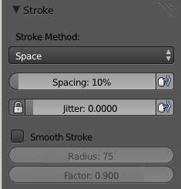
Stroke Panel
Stroke Method
Airbrush
Keep applying paint effect while holding mouse down (spray)
Space
Limit brush application to the distance specified by spacing (see below)
Dots
Apply paint on each mouse move step
Rate (only for Airbrush)
Interval between paints for airbrush
Spacing (only for Space)
Limit brush application to the distance specified by spacing
Jitter
Jitter the position of the brush while painting
Smooth Stroke
Brush lags behind mouse and follows a smoother path
Radius
Minimum distance from last point before stroke continues
Factor
Higher values give a smoother stroke

The brush Falloff curve
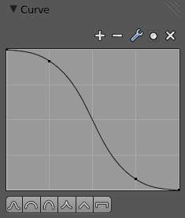
Curve Panel
The brush falloff editor allows you to specify the characteristics of your brushes to a large extent. The usage should be obvious and intuitive.

The brush appearance
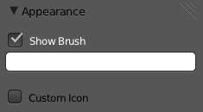
Brush appearance
Show Brush
makes the brush visible as a circle (on by default)
Color setter
To define the color of the brush circle
Custom icon
Allows definition of a custom brush icon

Brush presets
Bforartists provides several Brush presets:
- Mix, Draw, Brush : uses the Mix Blending mode to draw the brush weight with varying strength and brush falloff
- Add : uses the Add Blending mode
- Subtract : uses the Subtract Blending mode
- Lighten : uses the Lighten Blending mode
- Darken : uses the Darken Blending mode
- Multiply :uses the Multiply Blending mode
- Blur : uses the Blur Blending mode

Customizing brush color space
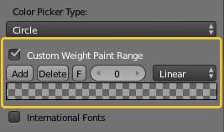
Customizing the Color Band
Bforartists allows customization of the color range used for the Weight Paint colors. You can define the color band as you like; for example, you can make it purely black/white if you prefer, you can even use alpha values here.
You find the customizer in the User Properties section, in the System Tab.

Selection Masking
If you have a complex mesh, it is sometimes not easy to paint on all vertices in Weight Paint mode. Suppose you only want to paint on a small area of the Mesh and keep the rest untouched. This is where selection masking comes into play. When this mode is enabled, a brush will only paint on the selected verts or faces. The option is available from the footer menu bar of the 3D viewport (see icons surrounded by the yellow frame):
You can choose between Face Selection masking (left icon) and Vertex selection masking (right icon).
Select mode has some advantages over the default Weight Paint mode:
- The original mesh edges are drawn, even when modifiers are active.
- You can select faces to restrict painting to the vertices of the selected faces.
- Selecting tools include:

Details about selecting
The following standard selection operations are supported:
- RMB - Single faces. Use Shift-RMB to select multiple.
- A - All faces, also to de-select.
- B - Block/Box selection.
- C - Select with brush.
- L - Pick linked (under the mouse cursor).
- Ctrl-L - Select linked.
- Ctrl-I - Invert selection (Inverse).

Tip
Selecting Deform Groups
When you are doing weight painting for deform bones (with an Armature), you can select a deform group by selecting the corresponding bone. However, this Vertex Group selection mode is disabled when Selection Masking is active!

Vertex Selection Masking
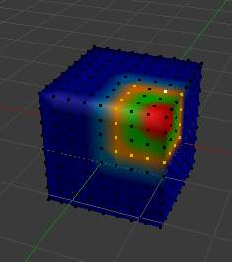
Vertex Selection masking
In this mode you can select one or more vertices and then paint only on the selection. All unselected vertices are protected from unintentional changes.

Face Selection Masking
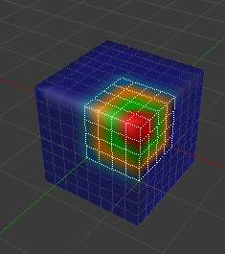
Face Selection masking
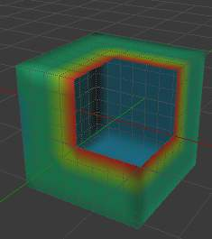
hidden faces
The Face Selection masking allows you to select faces and limit the weight paint tool to those faces, very similar to Vertex selection masking.

Hide/Unhide Faces
You also can hide selected faces as in Edit Mode, then paint on the remaining visible faces and finally unhide the hidden faces again

Hide/Unhide Vertices
You cannot directly hide selected faces in vertex mask selection mode. However you can use a trick:
- First go to Face selection mask mode
- Select the areas you want to hide and then hide the faces (as explained above)
- Switch back to Vertex Selection mask mode
Now the verts belonging to the hidden Faces will remain hidden.

The Clipping Border
To constrain the paint area further you can use the Clipping Border. The selected area will be “cut out” as the area of interest. The rest of the 3D window gets hidden.
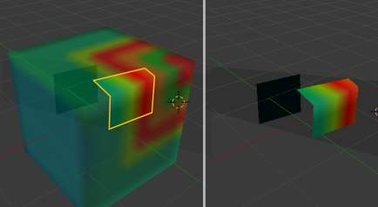
The Clipping Border is used to select interesting parts for local painting
You make the entire mesh visible again by calling the Clipping Border tool again. It's a toggle.
All weight paint tools that use the view respect this clipping, including border select, weight gradient and of course brush strokes.

Weight Paint Options
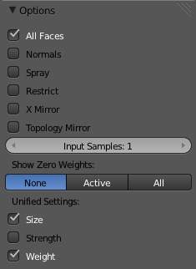
Weight Paint Options
The Weight Paint Options modify the overall brush behavior:
Normals
The vertex normal (helps) determine the extent of painting. This causes an effect as if painting with light.
Spray
This option accumulates weights on every mouse move.
Restrict
This option limits the influence of painting to vertices belonging (even with weight 0) to the selected vertex group.
X-mirror
Use the X-mirror option for mirrored painting on groups that have symmetrical names, like with extension .R / .L, or _R / _L. If a group has no mirrored counterpart, it will paint symmetrically on the active group itself. You can read more about the naming convention in Editing Armatures: Naming conventions. The convention for armatures/bones apply here as well.
Topology Mirror
Use topology-based mirroring, for when both side of a mesh have matching mirrored topology.
Input Samples
not so sure
Show Zero Weights
- None
- Active
- All
Unified Settings: The Size, Strength and Weight of the brush can be set to be shared across different brushes, as opposed to per-brush.
- Spray: to constantly draw (opposed to drawing one stroke per mouse click).
- Restrict: to only paint on vertices which already are weighted in the active weight group. (No new weights are created; only existing weights are modified.)
- x-mirror: to draw symmetrically. Note the this only works when the character symmetry plane is z-y (character looks into y direction).
- Show Zero weights: To display unreferenced and zero weighted areas in black (by default).

Weight Paint Tools
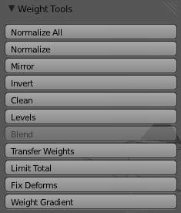
Weight Paint Tools
Bforartists provides a set of helper tools for Weight Painting. The tools are located in the weight tools panel.
The weight paint tools are full described in the Weight Paint Tools page

Weight Painting for Bones
This is one of the main uses of weight painting. When a bone moves, vertices around the joint should move as well, but just a little, to mimic the stretching of the skin around the joint. Use a “light” weight (10-40%) paint on the vertices around the joint so that they move a little when the bone rotates. While there are ways to automatically assign weights to an armature (see the Armature section), you can do this manually. To do this from scratch, refer to the process below. To modify automatically assigned weights, jump into the middle of the process where noted:
- Create an armature.
- Create a mesh that will be deformed when the armature’s bone(s) move.
- With the mesh selected, create an Armature modifier for your mesh (located in the Editing context, Modifiers panel). Enter the name of the armature.
Pick up here for modifying automatically assigned weights.
- Select the armature in 3D View, and bring the armature to Pose mode
- Select a desired bone in the armature.
- Select your mesh (using RMB) and change immediately to Weight Paint mode. The mesh will be colored according to the weight (degree) that the selected bone movement affects the mesh. Initially, it will be all blue (no effect).
- Weight paint to your heart’s content. The mesh around the bone itself should be red (generally) and fade out through the rainbow to blue for vertices farther away from the bone.
You may select a different bone with RMB while weight painting, provided the armature was left in Pose mode as described above. This will activate the vertex group sharing the name with the selected bone, and display related weights. If the mesh skins the bones, you will not be able to see the bones because the mesh is painted. If so, turn on X-Ray view (Buttons window, Editing context, Armature panel).
If you paint on the mesh, a vertex group is created for the bone. If you paint on vertices outside the group, the painted vertices are automatically added to the vertex group.
If you have a symmetrical mesh and a symmetrical armature you can use the option X-Mirror. Then the mirrored groups with the mirrored weights are automatically created.

Weight Painting for Particles
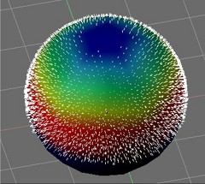
Weight painted particle emission.
Faces or vertices with zero weight generate no particles. A weight of 0. 1 will result in 10% of the amounts of particles. This option “conserves” the total indicated number of particles, adjusting the distributions so that the proper weights are achieved while using the actual number of particles called for. Use this to make portions of your mesh hairier than others by weight painting a vertex group, and then calling out the name of the vertex group in the VGroup: field (Particles panel, Object context).

Weight Tools

Weight Paint Tools
Bforartists provides a set of helper tools for Weight Painting. The tools are accessible from the Tool Shelf in Weight Paint mode. And they are located in the weight tools panel.

The Subset Option
Some of the tools also provide a Subset parameter (in the Operator panel, displayed after the tool is called) with following options:
- Active Group
- Selected Pose Bones
- Deform pose Bones
- All Groups
All tools also work with Vertex Selection Masking and Face Selection masking. In these modes the tools operate only on selected verts or faces.
Tip
About the Blend tool
The Blend tool only works when “Vertex selection masking for painting” is enabled. Otherwise the tool button is grayed out.

Normalize All
For each vertex, this tool makes sure that the sum of the weights across all Vertex Groups is equal to 1. This tool normalizes all of the vertex groups, except for locked groups, which keep their weight values untouched.

Operator Parameters
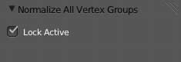
Normalize All Options
Lock Active
Keep the values of the active group while normalizing all the others.
Note
Currently this tool normalizes ALL vertex groups except the locked vertex groups.

Normalize
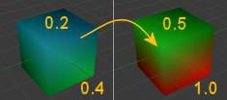
Normalize All Options
This tool only works on the active Vertex Group. All vertices keep their relative weights, but the entire set of weights is scaled up such that the highest weight value is 1.0

Mirror
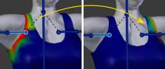
Normalize All Options
This tool mirrors the weights from one side of the mesh to the opposite side (only mirroring along x-axis is supported). But note, the weights are not transferred to the corresponding opposite bone weight group. The mirror only takes place within the selected Vertex Group.

Operator Parameters
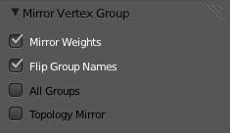
Mirror Options
Mirror Weights
Mirrors the weights of the active group to the other side. Note, this only affects the active weight group.
Flip Group Names
Exchange the names of left and right side. This option only renames the groups.
All Groups
Operate on all selected bones.
Topology Mirror
Mirror for meshes which are not 100% symmetric (approximate mirror).
Tip
Mirror to opposite bone
If you want to create a mirrored weight group for the opposite bone (of a symmetric character), then you can do this:
- Delete the target Vertex Group (where the mirrored weights will be placed)
- Create a copy of the source bone Vertex Group (the group containing the weights which you want to copy)
- Rename the new Vertex Group to the name of the target Vertex Group (the group you deleted above)
- Select the Target Vertex Group and call the Mirror tool (use only the Mirror weights option and optionally Topology Mirror if your mesh is not symmetric)

Invert
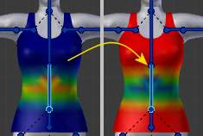
Invert
Replaces each Weight of the selected weight group by 1.0 - weight.
Examples:
- original 1.0 converts to 0.0
- original 0.5 remains 0.5
- original 0.0 converts to 1.0

Operator Parameters
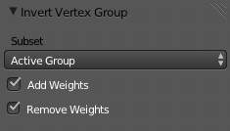
Mirror Options
Subset
Restrict the tool to a subset. See above (The Subset Option) about how subsets are defined.
Add Weights
Add verts that have no weight before inverting (these weights will all be set to 1.0)
Remove Weights
Remove verts from the Vertex Group if they are 0.0 after inverting.
Note
Locked vertex Groups are not affected.

Clean
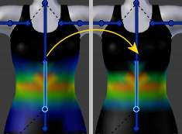
Invert
Removes weights below a given threshold. This tool is useful for clearing your weight groups of very low (or zero-) weights.
In the example shown, I used a cutoff value of 0.139 (see operator options below) so all blue parts (left side) are cleaned out (right side).
Note, the images use the Show Zero weights =Active option so that unreferenced Weights are shown in Black.

Operator Parameters
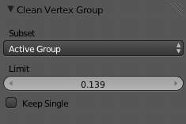
Mirror Options
Subset
Restrict the tool to a subset. See above (The Subset Option) for how subsets are defined.
Limit
This is the minimum weight value that will be kept in the Group. Weights below this value will be removed from the group.
Keep Single
Ensure that the Clean tool will not create completely unreferenced verts (verts which are not assigned to any Vertex Group), so each vertex will keep at least one weight, even if it is below the limit value!

Levels
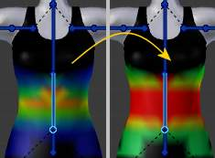
Invert
Adds an offset and a scale to all weights of the selected Weight Groups. with this tool you can raise or lower the overall “heat” of the weight group.
Note
No weight will ever be set to values above 1.0 or below 0.0 regardless of the settings.

Operator Parameters
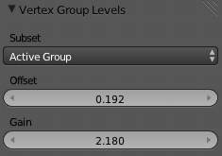
Mirror Options
Subset
Restrict the tool to a subset. See above (The Subset Option) for how subsets are defined.
Offset
A value from the range [-1.0,1.0]) to be added to all weights in the Vertex Group.
Gain
All weights in the Subset are multiplied with the gain. The drag sliders of this value allow only a range of [-10.0, 10.0]. However, you can enter any factor you like here by typing from the keyboard.
Note
Whichever Gain and Offset you choose, in all cases the final value of each weight will be clamped to the range [0.0, 1.0]. So you will never get negative weights or overheated areas (weight > 1.0) with this tool.

Blend
Blends the weights of selected vertices with adjacent unselected vertices. This tool only works in vertex select mode.
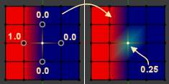
Blending
To understand what the tool really does, let’s take a look at a simple example. The selected vertex is connected to 4 adjacent vertices (marked with a gray circle in the image). All adjacent vertices are unselected. Now the tool calculates the average weight of all connected and unselected verts. In the example this is:
(1 + 0 + 0 + 0) / 4 = 0.25
This value is multiplied by the factor given in the Operator parameters (see below).
- If the factor is 0.0 then actually nothing happens at all and the vertex just keeps its value.
- If the factor is 1.0 then the calculated average weight is taken (0.25 here).
- Dragging the factor from 0 to 1 gradually changes from the old value to the calculated average.
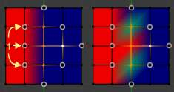
Blending
Now let’s see what happens when we select all but one of the neighbors of the selected vert as well. Again all connected and unselected verts are marked with a gray circle. When we call the Blend tool now and set the Factor to 1.0, then we see different results for each of the selected verts:
- The topmost and bottommost selected verts:
are surrounded by 3 unselected verts, with an average weight of (1 + 0 + 0) / 3 = 0.333 So their color has changed to light green.
- The middle vertex:
is connected to one unselected vert with weight = 1. So the average weight is 1.0 in this case, thus the selected vert color has changed to red.
- The right vert:
is surrounded by 3 unselected verts with average weight = (0 + 0 + 0) / 3 = 0.0 So the average weight is 0, thus the selected vert color has not changed at all (it was already blue before blend was applied).
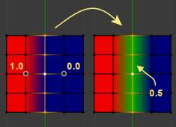
Blending
Finally let’s look at a practical example (and explain why this tool is named Blend). In this example I have selected the middle edge loop. And I want to use this edge loop for blending the left side to the right side of the area.
- All selected vertices have 2 unselected adjacent verts.
- The average weight of the unselected verts is (1 + 0) / 2 = 0.5
- Thus when the Blend Factor is set to 1.0 then the edge loop turns to green and finally does blend the cold side (right) to the hot side (left).

Operator Parameters
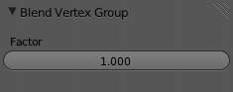
Blend Options
Factor
The effective amount of blending (range [0.0, 1.0]). When Factor is set to 0.0 then the Blend tool does not do anything. For Factor > 0 the weights of the affected vertices gradually shift from their original value towards the average weight of all connected and unselected verts (see examples above).

Transfer Weights
Copy weights from other objects to the vertex groups of the active Object. By default this tool copies all vertex groups contained in the selected objects to the target object. However you can change the tool’s behavior in the operator redo panel (see below).

Prepare the Copy
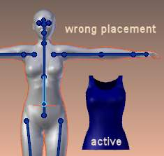  Blending | 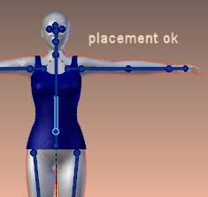  Blending
You first select all source objects, and finally the target object (the target object must be the active object).
It is important that the source objects and the target object are at the same location. If they are placed side by side, then the weight transfer won’t work. You can place the objects on different layers, but you have to ensure that all objects are visible when you call the tool.
Now ensure that the Target Object is in Weight Paint mode.

Call the Tool
Open the Tool Shelf and locate the Weight Tools panel. From there call the “Transfer weights” tool. The tool will initially copy all vertex groups from the source objects. However the tool also has an operator redo panel (which appears at the bottom of the tool shelf). From the redo panel you can change the parameters to meet your needs. (The available Operator parameters are documented below.)

Redo Panel Confusion
You may notice that the Operator Redo Panel (see below) stays available after the weight transfer is done. The panel only disappears when you call another Operator that has its own redo Panel. This can lead to confusion when you use Transfer weights repeatedly after you changed your vertex groups. If you then use the still-visible redo panel, then Bforartists will reset your work to its state right before you initially called the Transfer Weights tool.

Workaround
When you want to call the Transfer Weights tool again after you made some changes to your vertex groups, then always use the “Transfer Weights” Button, even if the operator panel is still available. Unless you really want to reset your changes to the initial call of the tool.

Operator Parameters
Note
This tool now uses the generic ‘data transfer’ one. Please refer to the Data Transfer Modifier for options details and explanations.

Limit Total
Reduce the number of weight groups per vertex to the specified Limit. The tool removes lowest weights first until the limit is reached.
Hint: The tool can only work reasonably when more than one weight group is selected.

Operator Parameters
Subset
Restrict the tool to a subset. See above (The Subset Option) for how subsets are defined.
Limit
Maximum number of weights allowed on each vertex (default:4)

Weight Gradient
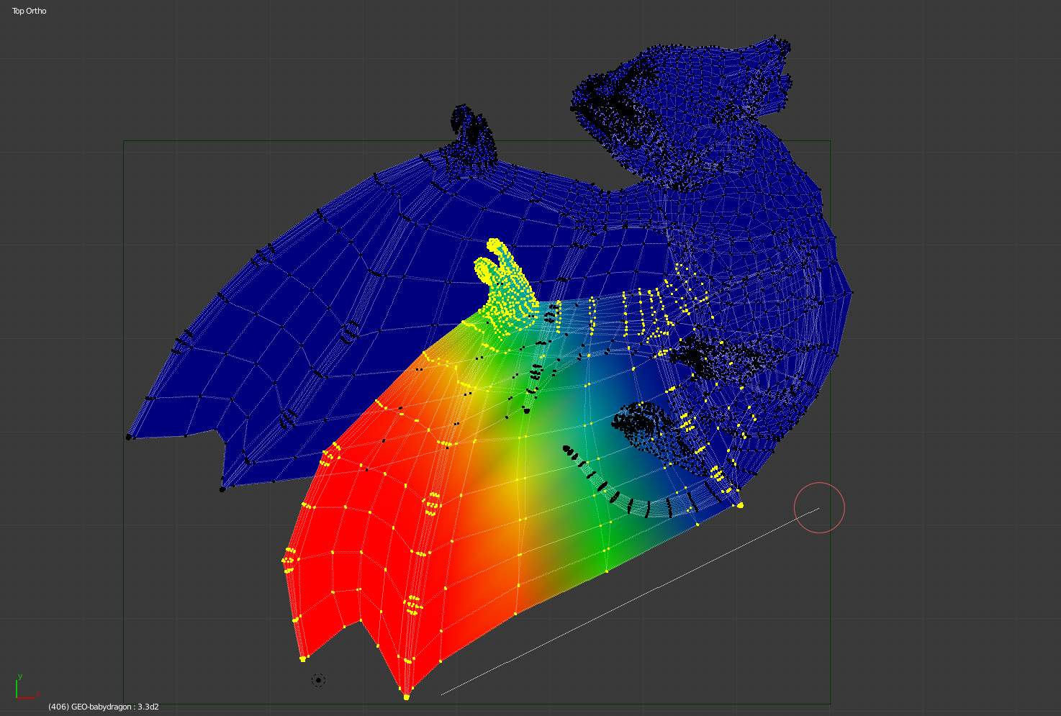
example of the gradient tool being used with selected vertices.
This is an interactive tool for applying a linear/radial weight gradient; this is useful at times when painting gradual changes in weight becomes difficult.
The gradient tool can be accessed from the Toolbar as a key shortcut:
- Linear: Alt-LMB and drag
- Radial: Alt-Ctrl-LMB and drag
The following weight paint options are used to control the gradient:
- Weight - The gradient starts at the current selected weight value, blending out to nothing.
- Strength - Lower values can be used so the gradient mixes in with the existing weights (just like with the brush).
- Curve - The brush falloff curve applies to the gradient too, so you can use this to adjust the blending.
Blends the weights of selected vertices with unselected vertices.
Hint
This tool only works in vertex select mode.

Operator Parameters
Type:
- Linear
- Radial
X Start: X End: Y Start: Y End:

Sculpting

Overview
Sculpt Mode is similar to Edit Mode in that it is used to alter the shape of a model, but Sculpt Mode uses a very different workflow: instead of dealing with individual elements (vertices, edges, and faces), an area of the model is altered using a brush. In other words, instead of selecting a group of vertices, Sculpt Mode automatically selects vertices based on where the brush is, and modifies them accordingly.

Sculpt Mode
Sculpt mode is selected from the mode menu of the 3D View header. Once sculpt mode is activated the Toolbar of the 3D View will change to sculpt mode specific panels. The panels in the toolbar will be Brush, Texture, Tool, Symmetry, Stroke, Curve, Appearance, and Options. Also a red circle will appear that follows the location of the cursor in the 3d view.
Note
To have a predictable brush behavior, apply the scale of your mesh.

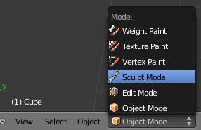
Sculpt Mode Dropdown.
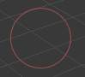
The cursor in Sculpt Mode.

Sculpt Brushes
Brushes are brush presets. They are a combination of a ‘tool’, along with stroke, texture, and options.
Sculpt Mode has sixteen brushes, each of which operates on the model in a unique way. Many can be toggled to have an additive or subtractive effect. They can be selected in the Tool menu.
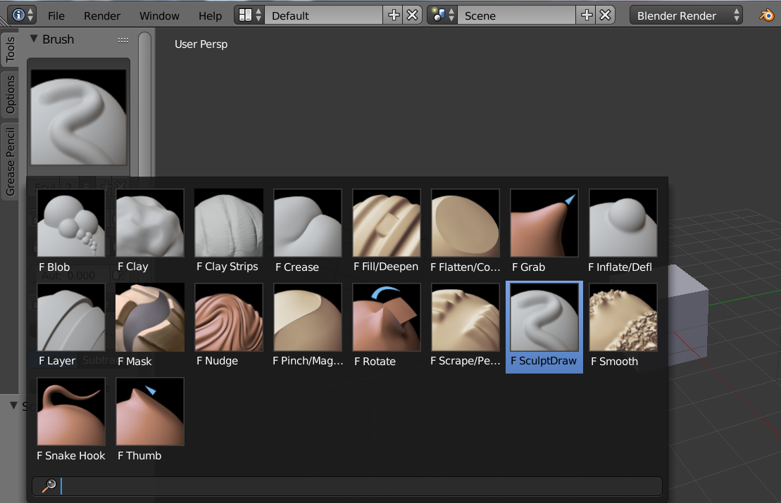
Sculpt brushes
Blob
Pushes mesh outward or inward into a spherical shape with settings to control the amount of pinching at the edge of the sphere.
Clay
Similar to the Draw brush, but includes settings to adjust the plane on which the brush acts.
Clay Strips
Similar to the Clay brush, but it uses a cube test to define the brush area of influence rather than a sphere.
Crease
Creates sharp indents or ridges by pushing or pulling the mesh, while pinching the vertices together.
Draw
Moves vertices inward or outward, based the average normal of the vertices contained within the drawn brush stroke.
Fill
The Fill brush works like the Flatten brush, but only brings vertices below the brush plane upwards. The inverse of the Scrape brush is to Deepen by pushing vertices above the plane downward.
Flatten
The Flatten brush finds an ‘area plane’ located by default at the average height above/below the vertices within the brush area. The vertices are then pulled towards this plane. The inverse of the Flatten brush is the Contrast brush which pushes vertices up or down away from the brush plane.
Grab
Grab is used to drag a group of points around. Unlike the other brushes, Grab does not modify different points as the brush is dragged across the model. Instead, Grab selects a group of vertices on mousedown, and pulls them to follow the mouse. The effect is similar to moving a group of vertices in Edit mode with proportional-editing enabled, except that Grab can make use of other Sculpt Mode options (like textures and symmetry).
Inflate
Similar to Draw, except that vertices in Inflate mode are displaced in the direction of their own normals.
Layer
This brush is similar to Draw, except that the height of the displacement layer is capped. This creates the appearance of a solid layer being drawn. This brush does not draw on top of itself; a brush stroke intersects itself. Releasing the mouse button and starting a new stroke will reset the depth and paint on top of the previous stroke.
Nudge
Moves vertices in the direction of the brush stroke.
Pinch
Pinch pulls vertices towards the center of the brush. The inverse setting is Magnify, in which vertices are pushed away from the center of the brush.
Rotate
Rotates vertices within the brush in the direction the cursor is moved.
Scrape
The Scrape brush works like the Flatten brush, but only brings vertices above the plane downwards. The inverse of the Scrape brush is to Peak by pushing vertices above the plane up away from the plane.
Smooth
As the name suggests, eliminates irregularities in the area of the mesh within the brush’s influence by smoothing the positions of the vertices.
Snake Hook
Pulls vertices along with the movement of the brush to create long, snake-like forms.
Thumb
Similar to the Nudge brush, this one flattens the mesh in the brush area, while moving it in the direction of the brush stroke.

Sculpt Properties Panel
This panel appears in the tool palette on the left side of the 3D viewport.

Brush Panel
Radius
This option controls the radius of the brush, measured in pixels. F in the 3D view allows you to change the brush size interactively by dragging the mouse and then left clicking (the texture of the brush should be visible inside the circle). Typing a number then enter while in F sizing allows you to enter the size numerically. Brush size can be affected by enabling the pressure sensitivity icon, if a supported tablet is being used.
Strength
Strength controls how much each application of the brush affects the model. For example, higher values cause the Draw brush to add depth to the model more quickly, and cause the Smooth brush to smooth the model more quickly. This setting is not available for Grab, Snake Hook, or Rotate.
If the range of strengths doesn’t seem to fit the model (for example, if even the lowest strength setting still makes too large of a change on the model) then you can scale the model (in Edit Mode, not Object Mode). Larger sizes will make the brush’s effect smaller, and vice versa. You can change the brush strength interactively by pressing Shift-F in the 3D view and then moving the brush and then left clicking. You can enter the size numerically also while in Shift-F sizing. Brush strength can be affected by enabling the pressure sensitivity icon, if a supported tablet is being used.
Autosmooth
Sets the amount of smoothing to be applied to each stroke.
Normal Weight
TODO.
Pinch Factor
TODO.
Rake Factor
TODO.
Sculpt Plane
Use this menu to set the plane in which the sculpting takes place.
Plane Offset
Adjusts the plane on which the brush acts toward or away from the viewer.
Height
TODO.
Trim
Enables trimming of the sculpt plane, determined by the Distance setting.
Front Faces Only
When enabled, the brush only affects vertices that are facing the viewer.
Accumulate
Causes stroke dabs to accumulate on top of each other.
Add/Subtract
TODO.
Persistent
TODO.

Stroke Panel
Stroke Method
Defines the way brush strokes are applied to the mesh:
Dots
Standard brush stroke.
Drag Dot
Creates a single displacement in the brush shape. Click then drag on mesh to desired location, then release.
Space
Creates brush stroke as a series of dots, whose spacing is determined by the Spacing setting. Spacing represents the percentage of the brush diameter.
Anchored
Creates a single displacement at the brush location. Clicking and dragging will resize the brush diameter. When Edge to Edge the brush location and orientation is determined by a two point circle, where the first click is one point, and dragging places the second point, opposite from the first.
Airbrush
Flow of the brush continues as long as the mouse click is held, determined by the Rate setting. If disabled, the brush only modifies the model when the brush changes its location. This option is not available for the Grab brush.
The following parameters are available for the Dots, Space, and Airbrush strokes:
Jitter
Jitters the position of the brush while painting.
Smooth stroke
Brush lags behind mouse and follows a smoother path. When enabled, the following become active:
Radius
Sets the minimum distance from the last point before stroke continues.
Factor
Sets the amount of smoothing

Curve Panel
The Curve section allows you to use a curve control to the right to modify the intensity of the brush from its centre (left part of the curve) towards its borders (right part of the curve).

See also
- Read more about using the Curve Widget.

Texture Panel
A texture can be used to determine the strength of brush effects as well. Select an existing texture from the texture box, or create a new one by selecting the New button
Brush Mapping
Sets the way the texture is mapped to the brush stroke:
Fixed
If Fixed is enabled, the texture follows the mouse, so it appears that the texture is being dragged across the model.
Tiled
The Tile option tiles the texture across the screen, so moving the brush appears to move separately from the texture. The Tile option is most useful with tileable images, rather than procedural textures.
3D
The 3D option allows the brush to take full advantage of procedural textures. This mode uses vertex coordinates rather than the brush location to determine what area of the texture to use.
Angle
This is the rotation angle of the texture brush. It can be changed interactively via Ctrl-F in the 3D view. While in the interactive rotation you can enter a value numerically as well. Can be set to:
User
Directly input the angle value.
Rake
Angle follows the direction of the brush stroke. Not available with 3D textures.
Random
Angle is randomized.
Offset
Fine tunes the texture map placement in the x, y, and z axes.
Size
This setting allows you to modify the scaling factor of the texture. Not available for Drag textures.
Sample Bias
Value added to texture samples.

Symmetry Panel
Mirror
Mirror the brush strokes across the selected local axes. Note that if you want to alter the directions the axes point in, you must rotate the model in Edit Mode, not Object Mode
Radial
These settings allow for radial symmetry in the desired axes. The number determines how many times the stroke will be repeated within 360 degrees around the central axes.
Feather
Reduces the strength of the stroke where it overlaps the planes of symmetry.
Lock
These three buttons allow you to block any modification/deformation of your model along selected local axes, while you are sculpting it.
Tiling
Using this option allows you to seamlessly tile your strokes along the given axes.
Tile Offset
The default tile size is set to one BU (Bforartists Unit). The offset allows the option to alter the tile size along all three axes.

Overlay Panel
When enabled, the brush texture is shown in the viewport
View
The eye icon is used as a toggle to show or hide the given brush texture
Alpha
You can change the amount of transparency used when showing the texture using the Alpha slider
Stroke Overlay
The brush icon allows you to turn off the viewport overlay during strokes

Options Panel
Gravity
Factor
Setting the factor allows you to add gravity to your brush strokes, giving it a draping effect.
Orientation
Using another object, the gravity can be oriented to the set object’s local Z axis, changing the direction of the gravity.
Threaded Sculpt
Takes advantage of multiple CPU processors to improve sculpting performance.
Fast Navigation
For Multires models, show low resolution while navigation the viewport.
Use Deform Only
Limits active modifiers on the active object to Deform modifiers, and Multiresolution
Show Diffuse Color
Allows the active object to show it’s diffuse color when sculpting
Unified Settings:
Size
Forces the brush size to be shared across brushes.
Strength
Forces the brush strength to be shared across brushes.
Color
Not Used in Sculpt Mode
Show Brush
Shows the brush shape in the viewport.
Color (Add/Subtract)
Set the color of the brush ring when its particular effect is active

Appearance Panel
Show Brush
Shows the brush shape in the viewport.
Color (Add/Subtract)
Set the color of the brush ring when its particular effect is active
Custom Icon
Append an image file to the active brush as an icon.

Sculpt Menus

Tool Menu
Here you can select the type of brush preset to use. Reset Brush will return the settings of a brush to its defaults. You can also set Bforartists to use the current brush for Vertex Paint mode, Weight Paint mode, and Texture Paint mode using the toggle buttons.

Hiding and Masking Mesh
It is sometimes useful to isolate parts of a mesh to sculpt on. To hide a part of a mesh, press H then click & drag around the part you want to hide. To reveal a hidden part of a mesh, press Shift-H then click & drag around the part you want to reveal. To reveal all hidden parts, just press Alt-H. With the mask brush we can paint a part of the mesh and hide it.
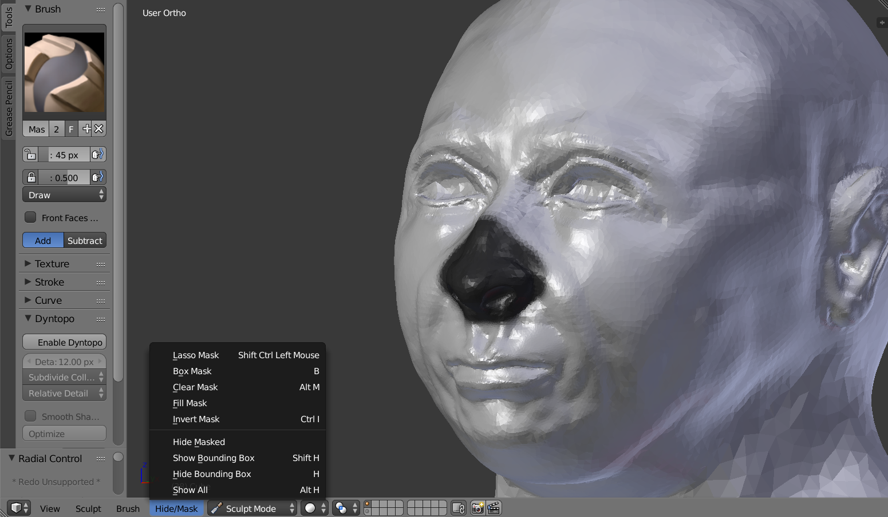
Black part is masked, down in the picture mask/hide menu

Adaptive Sculpting

Dynamic Topology
Dynamic topology (AKA dyntopo) is a dynamic tessellation sculpting method, adds and removes details on the fly. Dyntopo is quick, just get a brush and start to sculpt. Dyntopo will add details base upon your brush size, detail type and strength.
Detail Type
Dyntopo uses three different detail methods to create dynamic detail to an object. The methods available are Relative Detail (Default), Constant Detail, and Brush Detail.
Relative Detail
This method uses a detail size based on the number of pixels, and in turn will create topology in that size. Zoom out big details, zoom in small fines details.
Constant Detail
To keep detail uniform across the entire object, Constant Detail can be used. The Detail is based on the percentage of a single BU (Bforartists Unit).
Brush Detail
Giving more control over the topology, with this method you can create topology based on the brush size. You can increase and lower topology by simply resizing the brush itself. The detail size is based the size of the brush itself, where 100% will create topology the size of the brush ring itself.
Detail Size
Each Detail Type’s detail is set here. Depending on the Detail Type being used this property will rather show as a pixel count (px), or percentage.
Detail Refine Method
When using Dynamic Topology, a certain method will be used to tell how topology is handled. Setting the option will determine which of the methods will be used when altering the topology.
Subdivide
Just like the subdivide command, this method will only subdivide topology to match the detail given.
Collapse
When topology is too dense, and is smaller than the detail given, edges will be collapse to fit the detail size appropriately.
Subdivide Collapse
This method combines the two methods, subdividing edges smaller than the detail size, and collapsing topology.
Detail Flood Fill
When using Constant Detail mode, this option is made available, allowing you to fill the entire object with a uniform detail, based on the detail size.
Direction
Determines which direction the model will be symmetrized.
Dyntopo Symmetrize
Uses direction orientation to symmetrize. Since Dyntopo adds details dynamical may happen that the model goes asymmetric, so this a good tool for that.

Multi-Resolution Modifier
The multires modifier is needed to sculpt. The modifier will subdivide the mesh. The more subdivision the more computing will be needed. With the Bforartists stack no-destructive data, multires sculpting will help when you have a clean topology base mesh.
When sculpting with multires we have the ability sculpt in different level of subdivision, this mean we can sculpt some details in subdivision level 1 and add more details in subdivision 2 and go back to subdivision 1 correct some mistakes. While this workflow is often used, multires modifier has some limitations. You may end up with some mesh distortions. As an advice, add as more details as possible before adding more subdivisions. Clay brush, SculptDraw work better with multires sculpting to sculpt secondary forms.
See also
Read more about the Multi Resolution Modifier.

